PRESS RELEASE

COMMUNICATIONS AND MEDIA TEAM OF THE 2023 ASEAN SUMMIT

No.28/SP/TKM-ASEAN2023/ENG/5/2023

Indonesia Prioritizes COVID-19 Health Protocols at 42nd ASEAN Summit 2023 in Labuan Bajo

Jakarta, 5 May 2023 – Indonesian Ministry of Health has made the COVID-19 health protocol one of two priority concerns in welcoming the 42nd ASEAN Summit 2023 in Labuan Bajo, 9-11 May.

"Two points are prioritized in preparing for the Summit in Labuan Bajo. First, COVID-19 health protocol. Second, health facilities," said Deputy Minister of Health, Dante S. Harbuwono, in the Merdeka Barat 9 Forum Dialogue (FMB9) entitled 'Readiness of ASEAN Summit 2023', Friday, 5 May.

He said the government would facilitate VIP Head of Delegation and delegates with conveniences in following the health protocol, starting from administering complete vaccinations, registering the Satu Sehat application, verifying vaccine certificates, scanning Satu Sehat QR code, and measuring body temperature when entering the airport gate.

Apart from that, said Dante, his party also requires participants to take an antigen test that applies for 24 hours and a PCR test for 72 hours. The recommendation to wear a mask while in the room also applies to all participants present during the 42nd ASEAN Summit.

"We also provide RT-PCR facilities according to the needs of the delegates' destination countries prior to their departures," he added.

The available COVID-19 tests reached more than 1,200 specimens: the Komodo Hospital Lab with 765 tests per day and Siloam Hospital with 440 tests per day.

The Ministry of Health has also prepared procedures for testing and handling of COVID-19 for delegates and hotel employees. Rapid antigen negative test result within 24 hours prior to the time of check-in or negative PCR test result within 72 hours prior to check-in is required at hotels such as Meruorah, Ayana, Sudamala, Plataran Komodo, and Local Collection Hotels for delegates and guests starting from 7 May.

Meanwhile, antigen tests will be given within 24 hours on 6 May for hotel and convention center employees. They will stay in designated places and not return to their residences to ensure the services complies a safe protocol.

Medical Facility

Apart from health protocols, Dante added, his ministry prepares health facilities by providing two Mini ICUs at the main venues of the 42nd ASEAN 2023 Summit, five clinics, and nine Mobile Teams.

"We prepare one Mini ICU at the Meruorah Hotel and another at the Ayana Hotel. Meanwhile, five clinics will be provided in Merurah, Ayana, Sudamala, Palataran, and Laprima hotels. it’s to provide medical services for guests related to COVID-19 and other diseases," he added.

Additional Medical Personnel from Bali

In terms of the number of medical personnel assigned for the event, Dante explained that his party brought more than 100 medical personnel from Ngoerah Hospital, Bali, to be assigned as at swab test stations.

"So, we prepared are medical personnel to carry out swab tests. There are around more than 100 people from Ngoerah Hospital of Bali, and ready for duty there (Labuan Bajo) as of today," he said.

Dante added that his party is also coordinating to ensure that all infrastructure, SOPs, medical technical issues, and surveillance can run smoothly. "For the time being, we are bringing in medical personnel from outside Labuan Bajo," he said.

You can watch FMB9 on the FMB9ID_IKP YouTube channel. For accurate information updates and valid data from trusted sources, check out FMB9ID_ (Twitter), FMB9.ID (Instagram), FMB9.ID (Facebook). (FMB 9/TR/Elvira/WS/PPR)

***

For more information, please contact:

Director General of Public Information and Communications of the Ministry of Communications and Informatics - Usman Kansong (0816785320)

Get other information at http://asean2023.id, https://infopublik.id/kategori/asean-2023, and https://indonesia.go.id/kategori/ragam-asean-2023

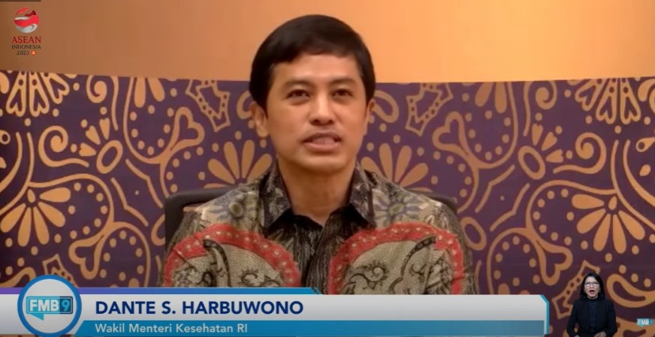

Deputy Minister of Health, Dante S. Harbuwono, in the Merdeka Barat 9 Forum Dialogue (FMB9) entitled 'Readiness for the 2023 ASEAN Summit', Friday, 5 May 2023. Indonesian Ministry of Health has made the COVID-19 health protocol one of two priority preparations in welcoming the 42nd ASEAN Summit 2023 in Labuan Bajo, 9-11 May 2023.

